## **Activity File: Exploring Kibana**

* You are a DevOps professional and have set up monitoring for one of your web servers. You are collecting all sorts of web log data and it is your job to review the data regularly to make sure everything is running smoothly.
* Today, you notice something strange in the logs and you want to take a closer look.
* Your task: Explore the web server logs to see if there's anything unusual. Specifically, you will:

⚠ **Heads Up**: These sample logs are specific to the time you view them. As such, your answers will be different from the answers provided in the solution file.

### **Instructions**

1. Add the sample web log data to Kibana.
2. Answer the following questions:  
   * In the last 7 days, how many unique visitors were located in India? **245**

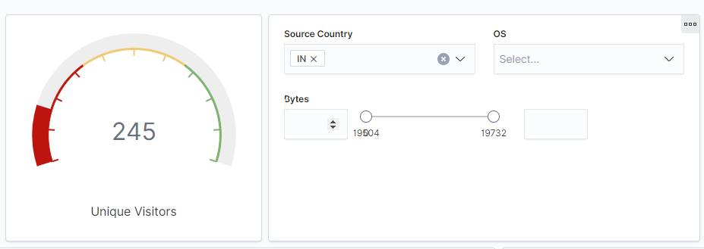

* + In the last 24 hours, of the visitors from China, how many were using Mac OSX? **10**

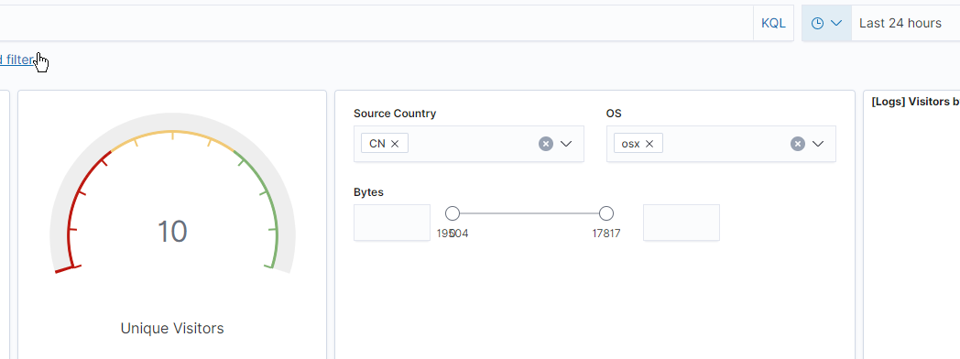

* + In the last 2 days, what percentage of visitors received 404 errors? How about 503 errors? **0% for 404 and 0% for 503? Data is only for the most recent time frame. For example on 2021-09-16 12:00 there were 0% 404 and 0% 503 errors, there is no way to find out the “percentage of 404 errors within the last 2 days” with this data**

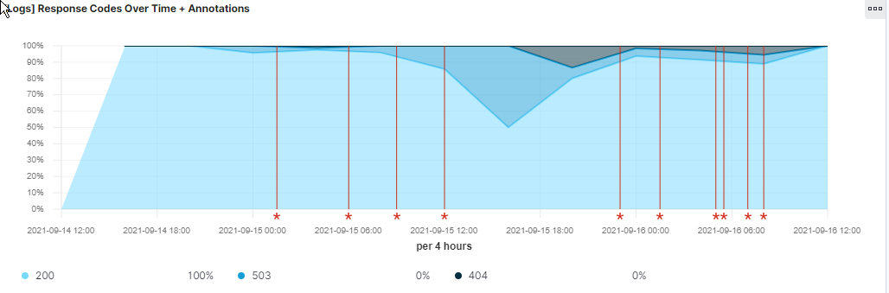

* + In the last 7 days, what country produced the majority of the traffic on the website? **CHINA**

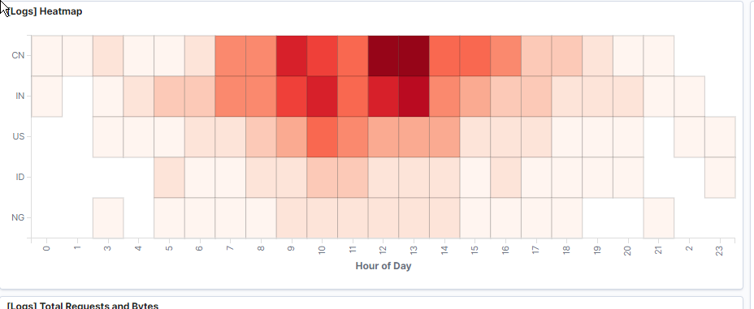

* + Of the traffic that's coming from that country, what time of day had the highest amount of activity? **13:00**  
    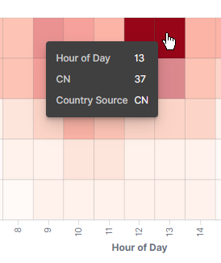
  + List all the types of downloaded files that have been identified for the last 7 days, along with a short description of each file type (use Google if you aren't sure about a particular file type).

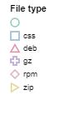  
**No extension - the file did not have an extension, css - used to modify the look of web elements and page layouts, deb - debian software package, gz file compressed by gnu gzip, rpm - red hat package manager file, zip - compressed archive file**

1. Now that you have a feel for the data, Let's dive a bit deeper. Look at the chart that shows Unique Visitors Vs. Average Bytes.  
   * Locate the time frame in the last 7 days with the most amount of bytes (activity). **9/12/21**

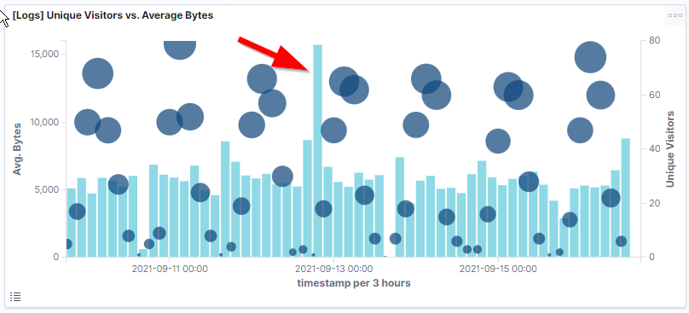

* + In your own words, is there anything that seems potentially strange about this activity? **A large amount of bytes was recorded however only 1 visitor visited the site**

1. Filter the data by this event.  
   * What is the timestamp for this event? **9/12/21 18:46**

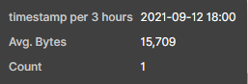

* + What kind of file was downloaded? **Deb file**
  + From what country did this activity originate? **china**
  + What HTTP response codes were encountered by this visitor? **200**

1. Switch to the Kibana Discover page to see more details about this activity.  
   * What is the source IP address of this activity? **28.11.251.5**
   * What are the geo coordinates of this activity? **{**
   * **"lat": 28.72751778,**
   * **"lon": -96.2509675**
   * **}**
   * What OS was the source machine running? **Win 8**
   * What is the full URL that was accessed? **https://artifacts.elastic.co/downloads/beats/metricbeat/metricbeat-6.3.2-amd64.deb**
   * From what website did the visitor's traffic originate?**http://nytimes.com/success/maksim-surayev**
2. Finish your investigation with a short overview of your insights.  
   * What do you think the user was doing? Downloading metricbeat
   * Was the file they downloaded malicious? If not, what is the file used for? **No, it is used to install metricbeat**
   * Is there anything that seems suspicious about this activity? **no**
   * Is any of the traffic you inspected potentially outside of compliance guidlines? **no**